**Project 2: Digital Footprint on Internet**

* Describe and draw a figure to show your network environment including the browser, the advertisement site, the social media site, and the Mobile or Camera store webpage that you access.

For this project, my network environment includes:

* The Browser
* The Advertisement sever
* A few commercial sites.

The VM file which I downloaded had preconfigured apache 2 server and few of the configured commercial sites DNS.



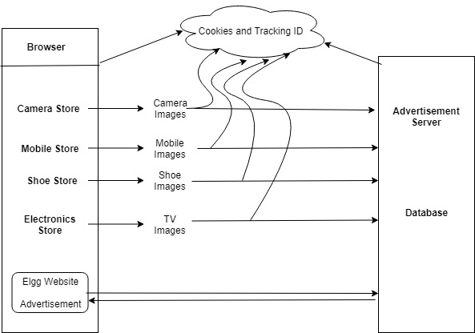

* Screen captures and explanations for the tasks 3.1 – 3.7 in the Project Description page 3 to page 7.

**Task 1:**

First and formost, I started the apache2 web server using the command “sudo service apache2 start”



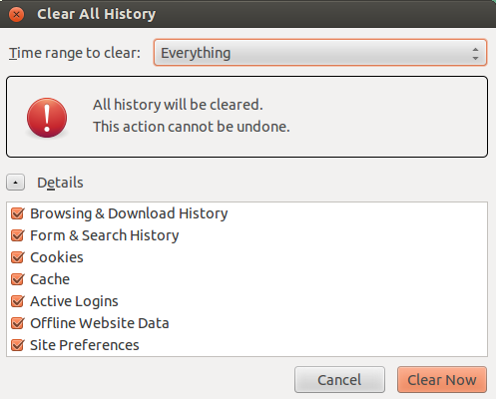Then, I cleared all the History and cookies from the Firefox browser options.

Then as I opened the Elgg website (<http://www.wtlabelgg.com>) without visiting any other website, I observed a login pane (for username and password). Furthermore, I did not see any advertisement being displayd on the webpage as there were no browsing history.

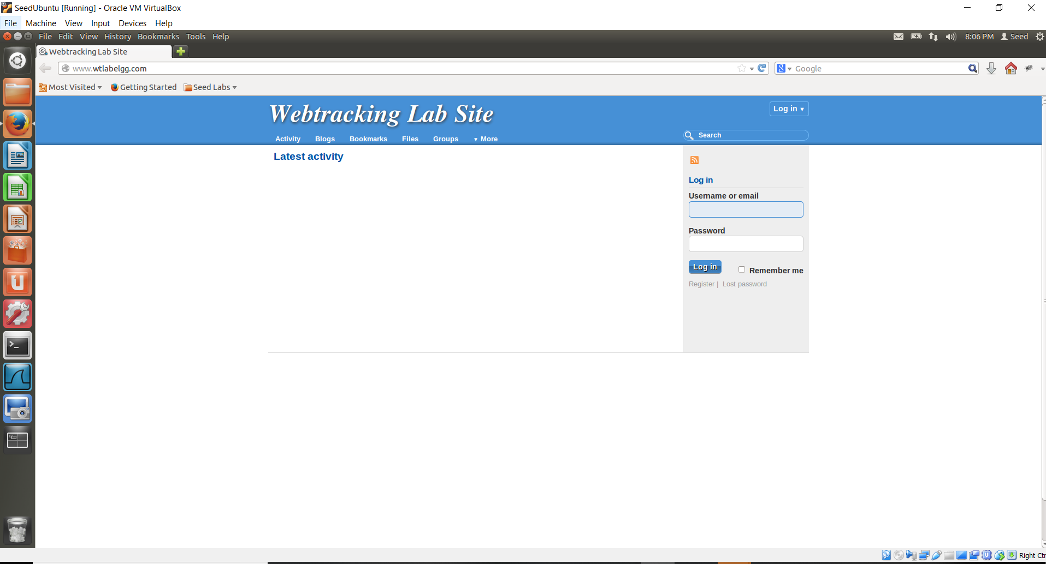

Then, I opened the following e-commerce websites:

* CameraStore (<http://www.wtcamerastore.com> )
* MobileStore (<http://www.wtmobilestore.com> )
* ElectronicStore (<http://www.wtelectronicsstore.com> )
* ShoeStore (<http://www.wtshoestore.com> )

I viewed some random product details on the mentioned websites as shown in the below screenshots:

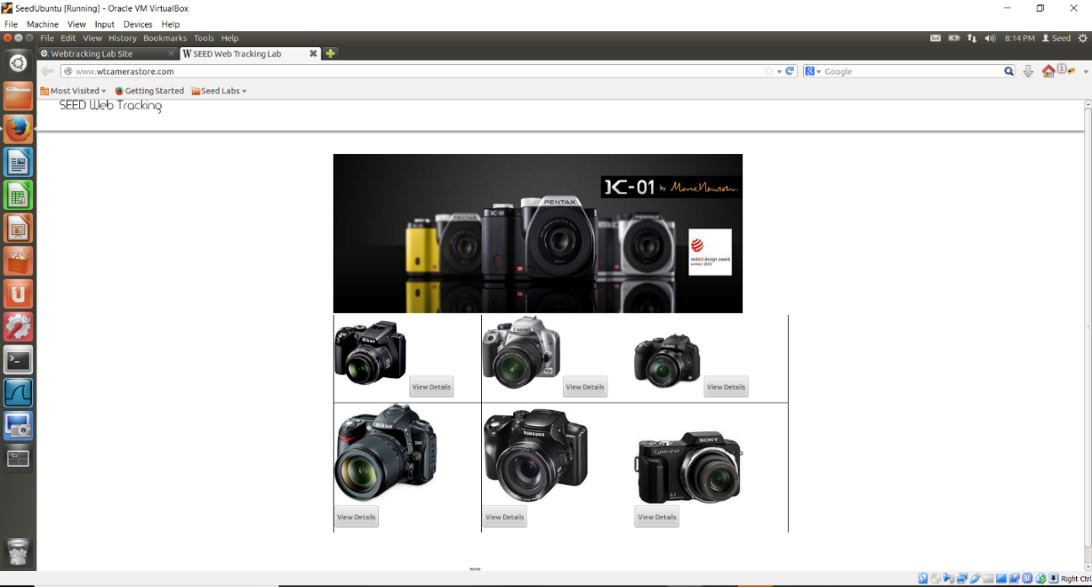

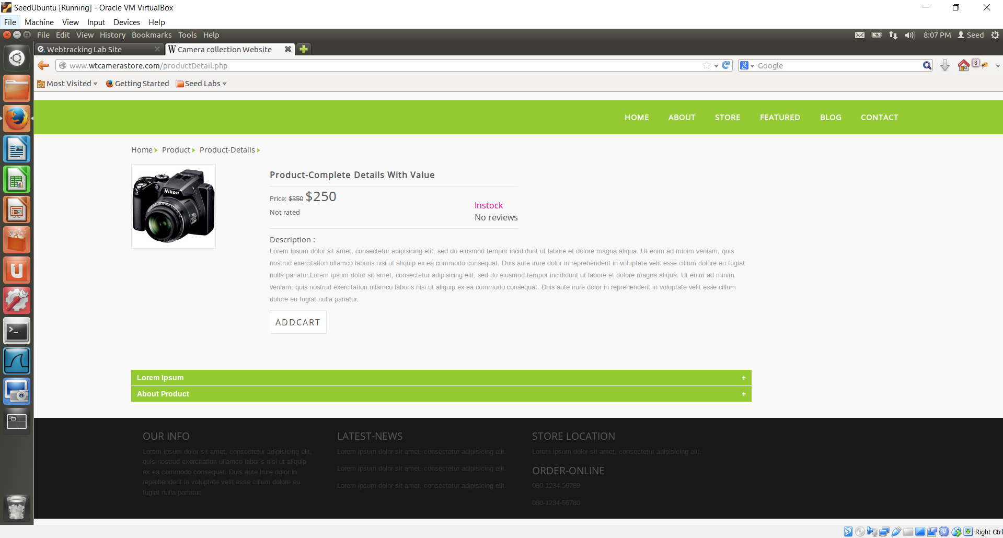

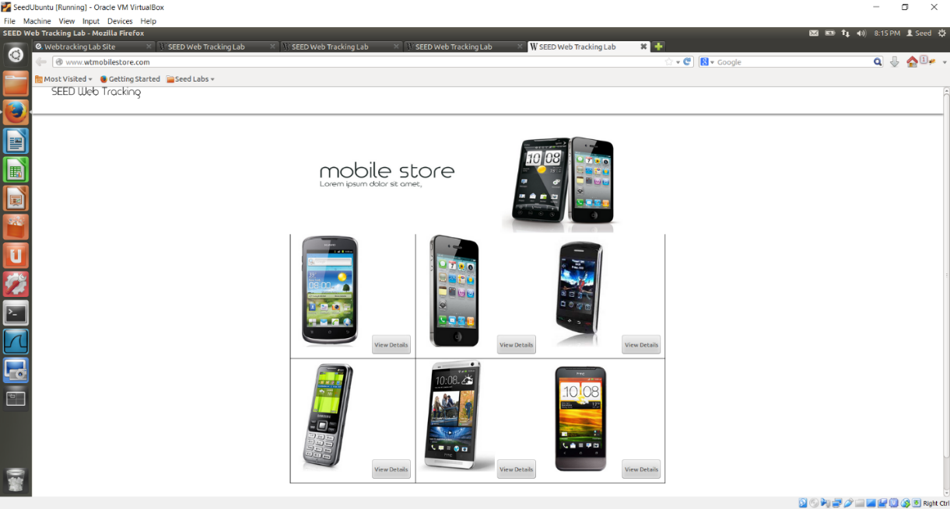

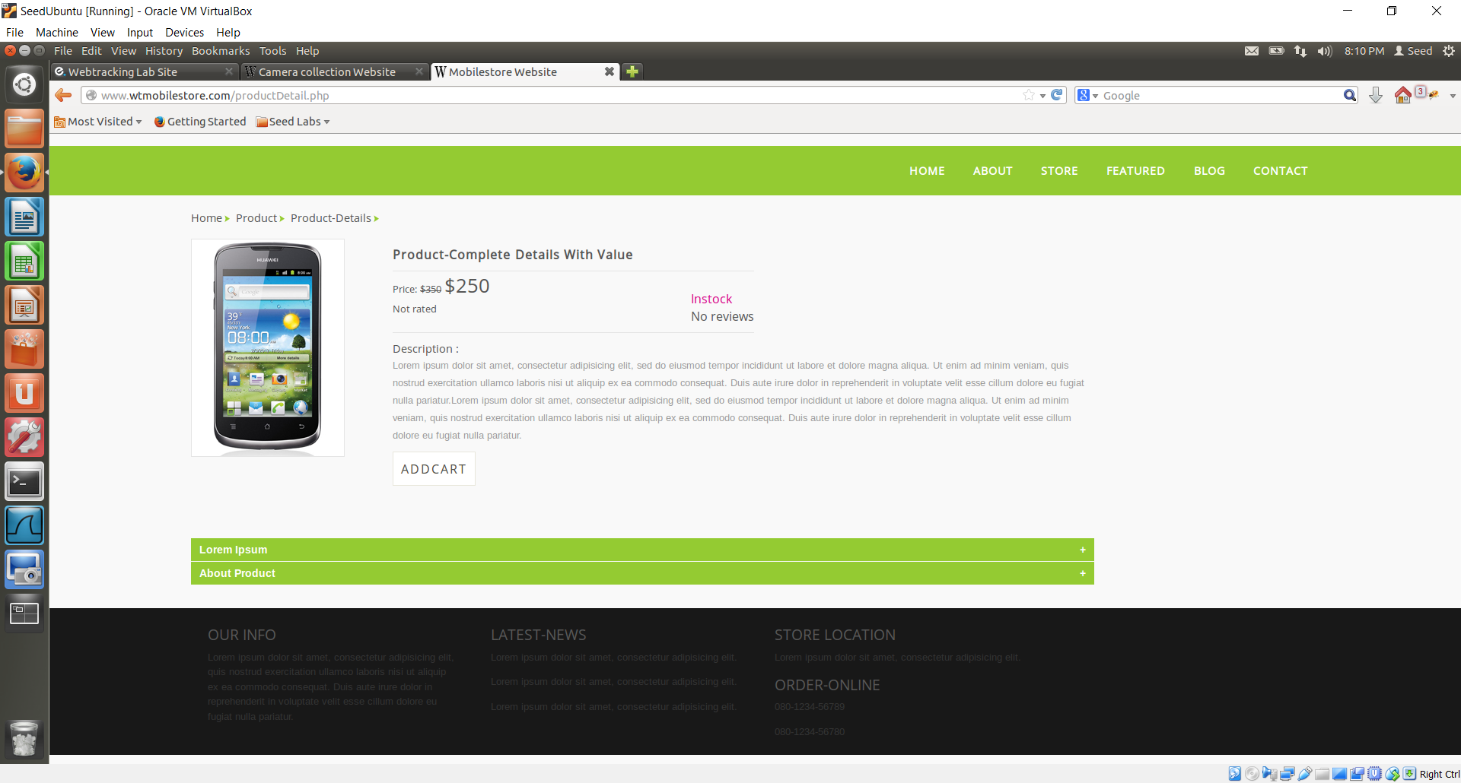

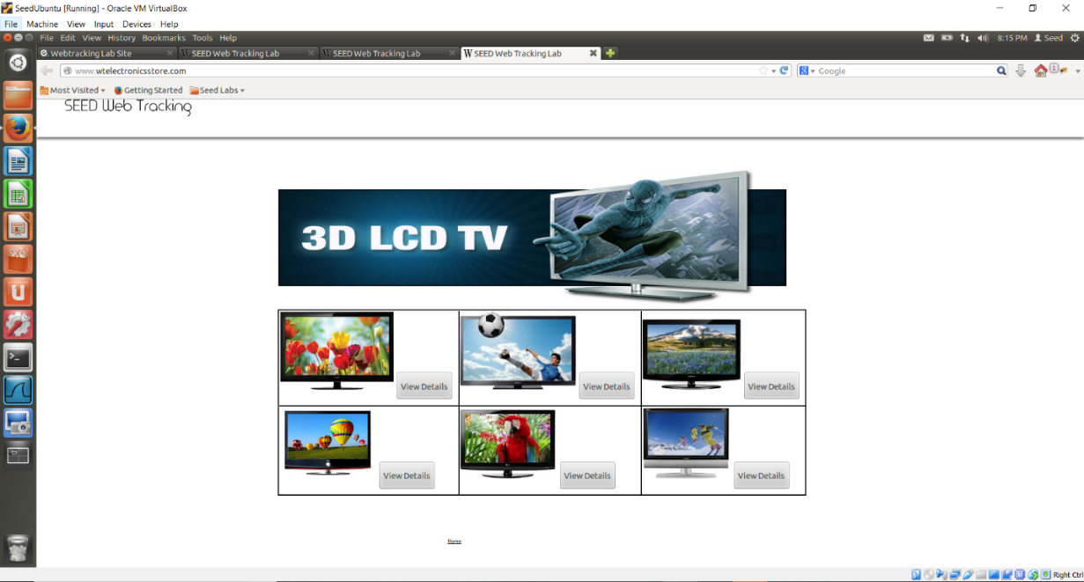

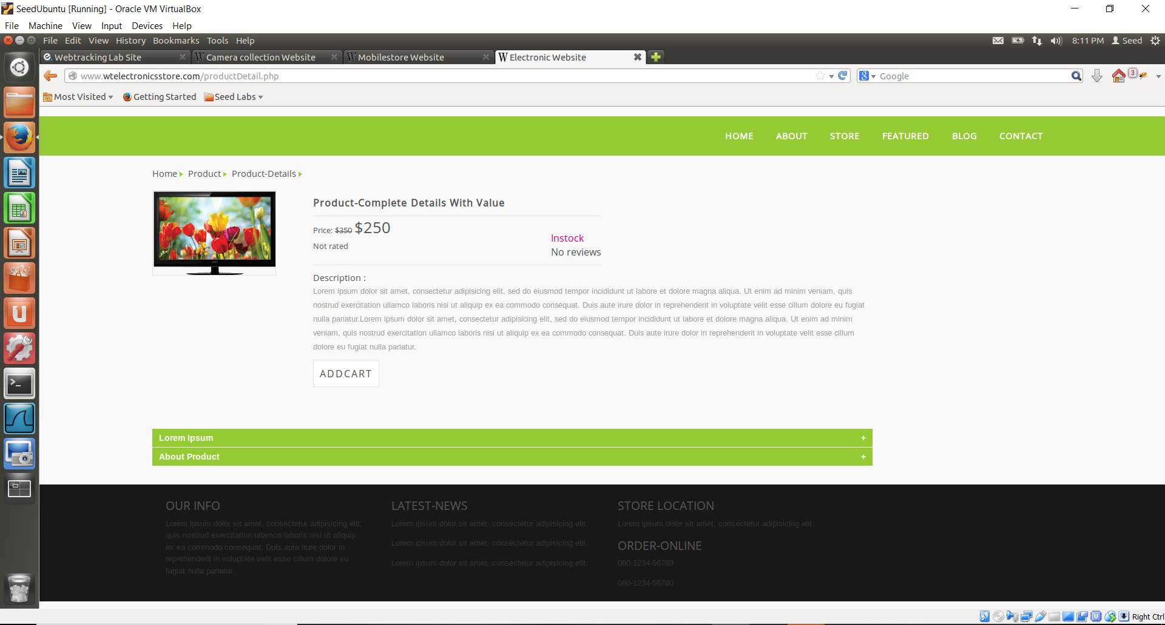

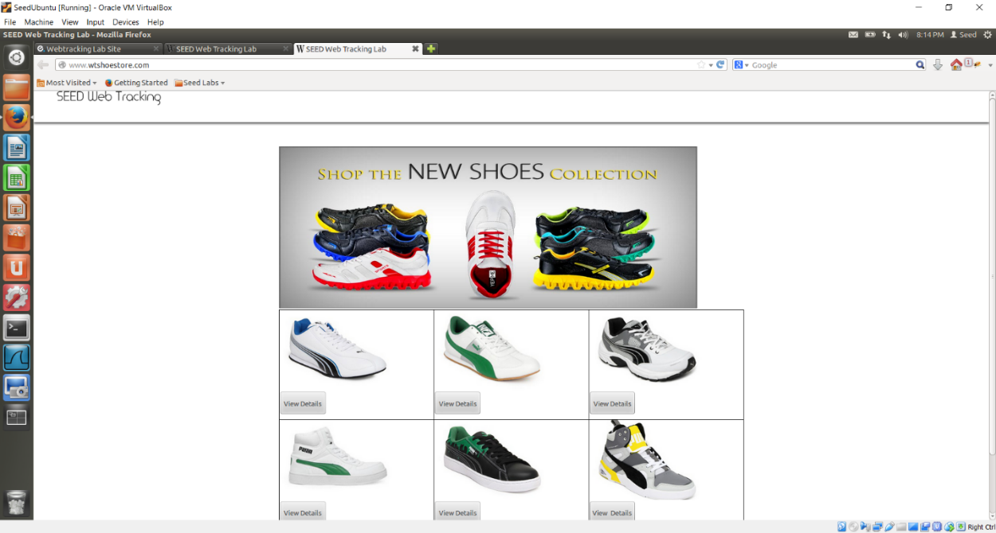

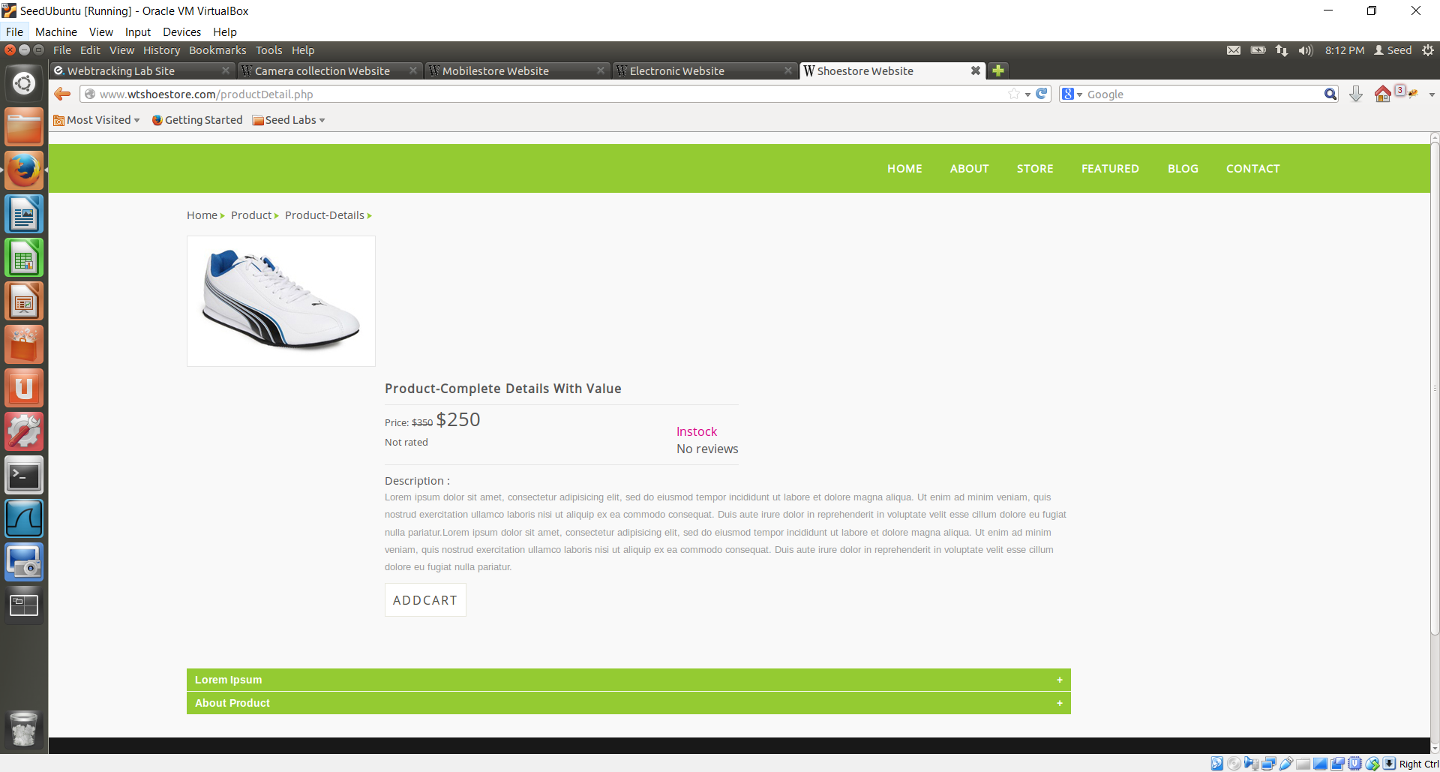

Upon refreshing the Elgg website, I could see a camera’s advertisement (which I visited earlier in CameraStore) being displayed on the webpage. This observation made me understand that the server somehow had the knowledge of my previous browsing/search results because of which it could show me the advertisement of a product which I was searching for.

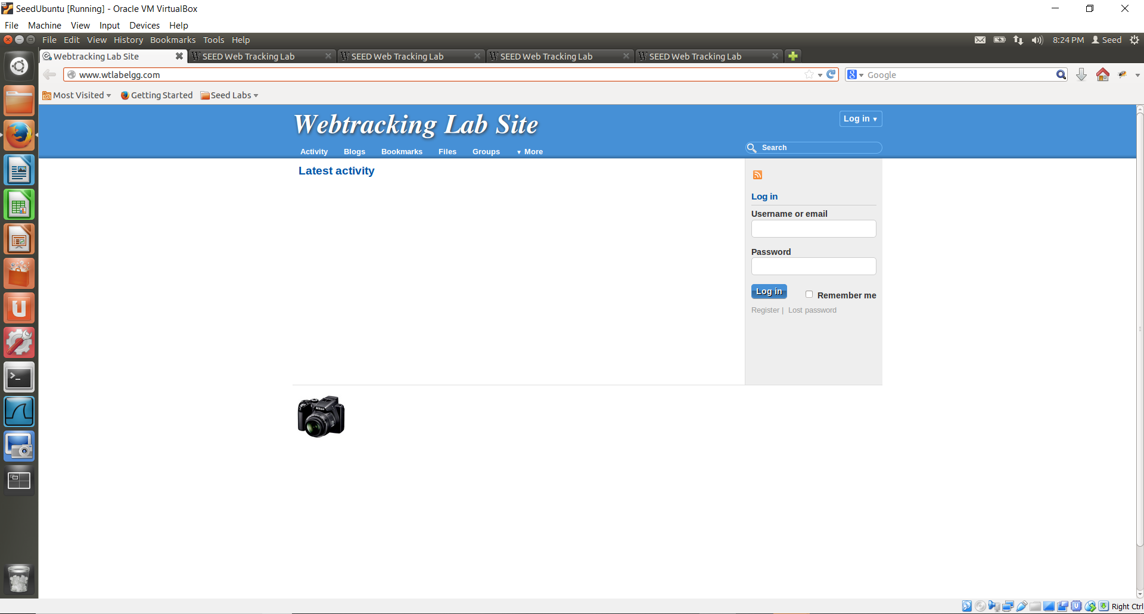

After closing and then reopening the browser, I could see that the same advertisement was being displayed on the web page. This tells me that the server will remember my previous searches/browsing history even if I close the session/browser.

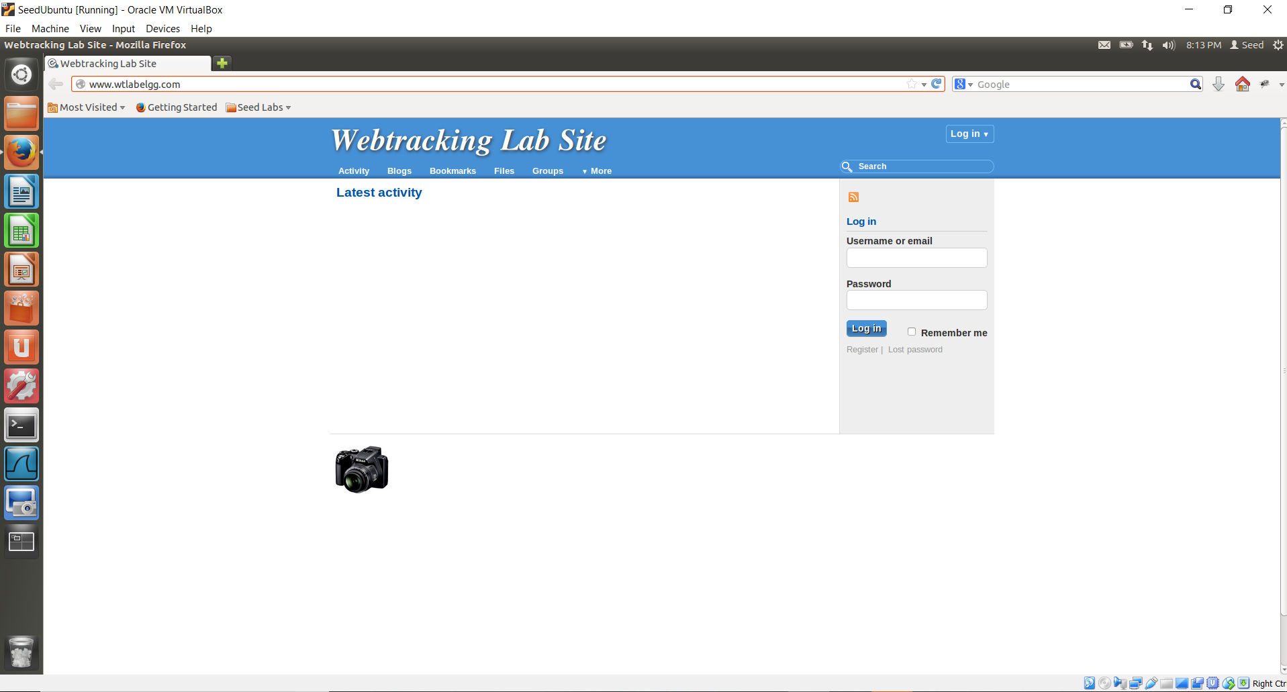

**Task 2:**  
I clicked on “View Details” of a random product on the camerastore website as shown below. Then, I opened up the “Live HTTP Headers”. I then identified the HTTP request, which set the third-party cookies and took a screenshot:

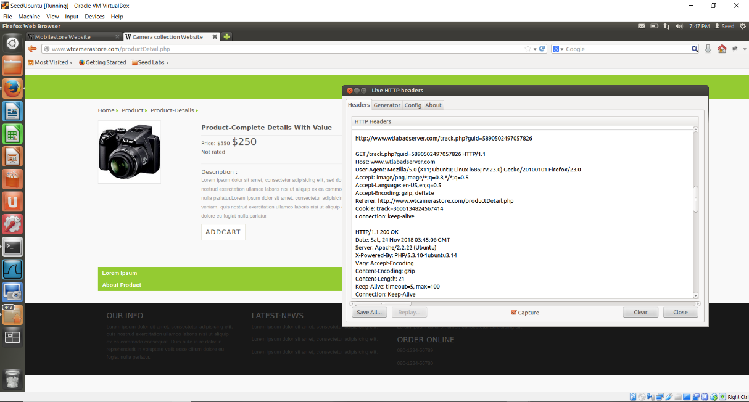

I right clicked on the Product Detail page and selected ‘View Page Source’. Here, I could see that the web page was sending a request for a ***tracking cookie*** along with the ***GUID***. This demonstrates how a request is sent to a third-party from an e-commerce website.

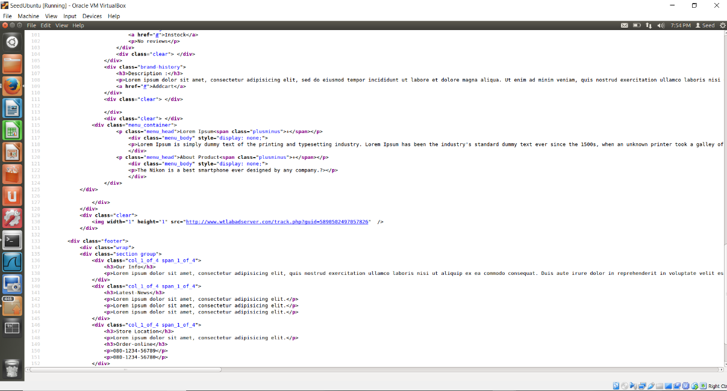

Enable the firebug on selected camera product to identify the third-party cookie. I noticed that the Firebug had no captured cookie. It doesn’t give you the tracking cookie that has the domain www.labadserver.com

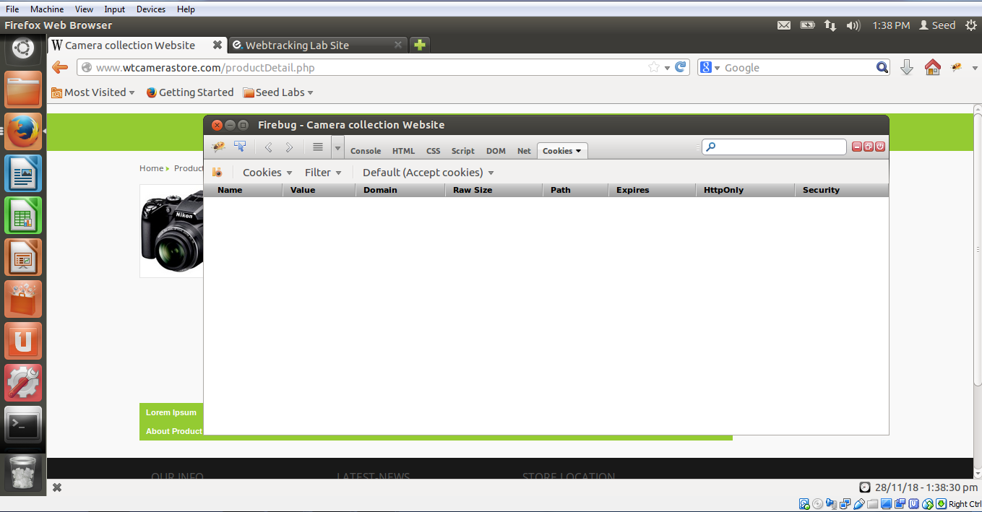

Then I launched ***Firebug*** after opening the ***www.labadserver.com*** and I found another cookie having a session ID. This session cookie indicates that it will expire immediately after the session is closed.

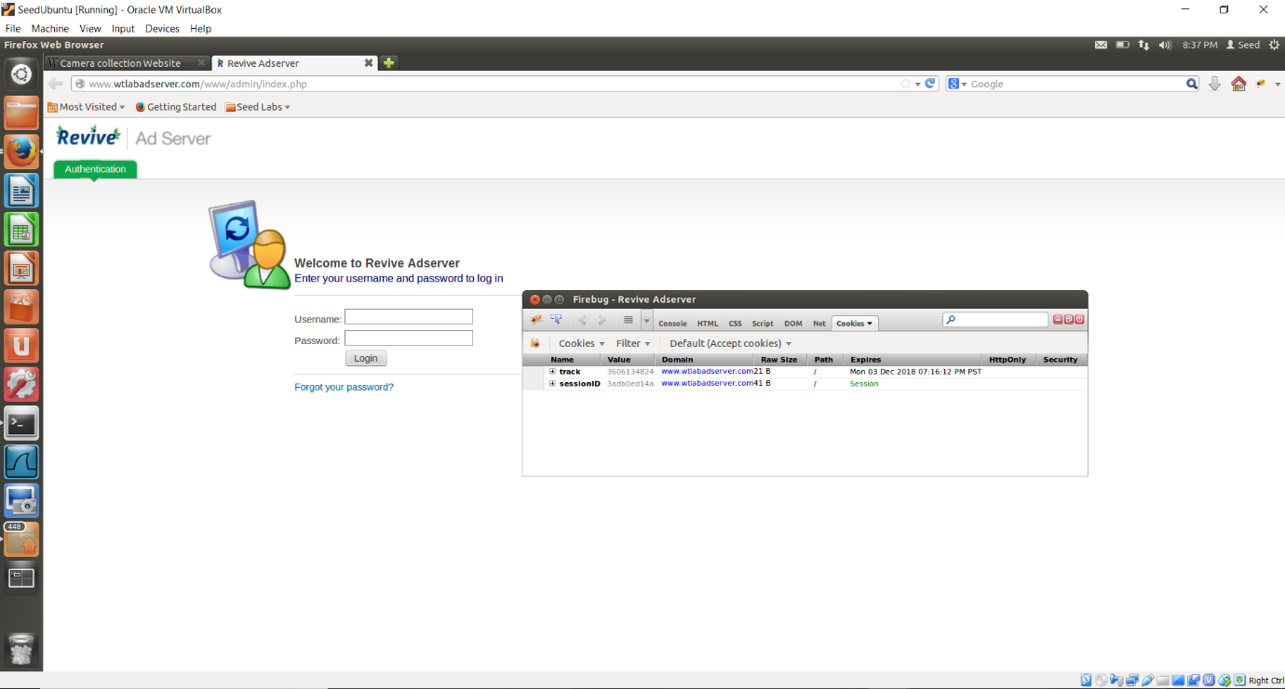

**Task 3:**

I opened up another random product detail page on camera store website:

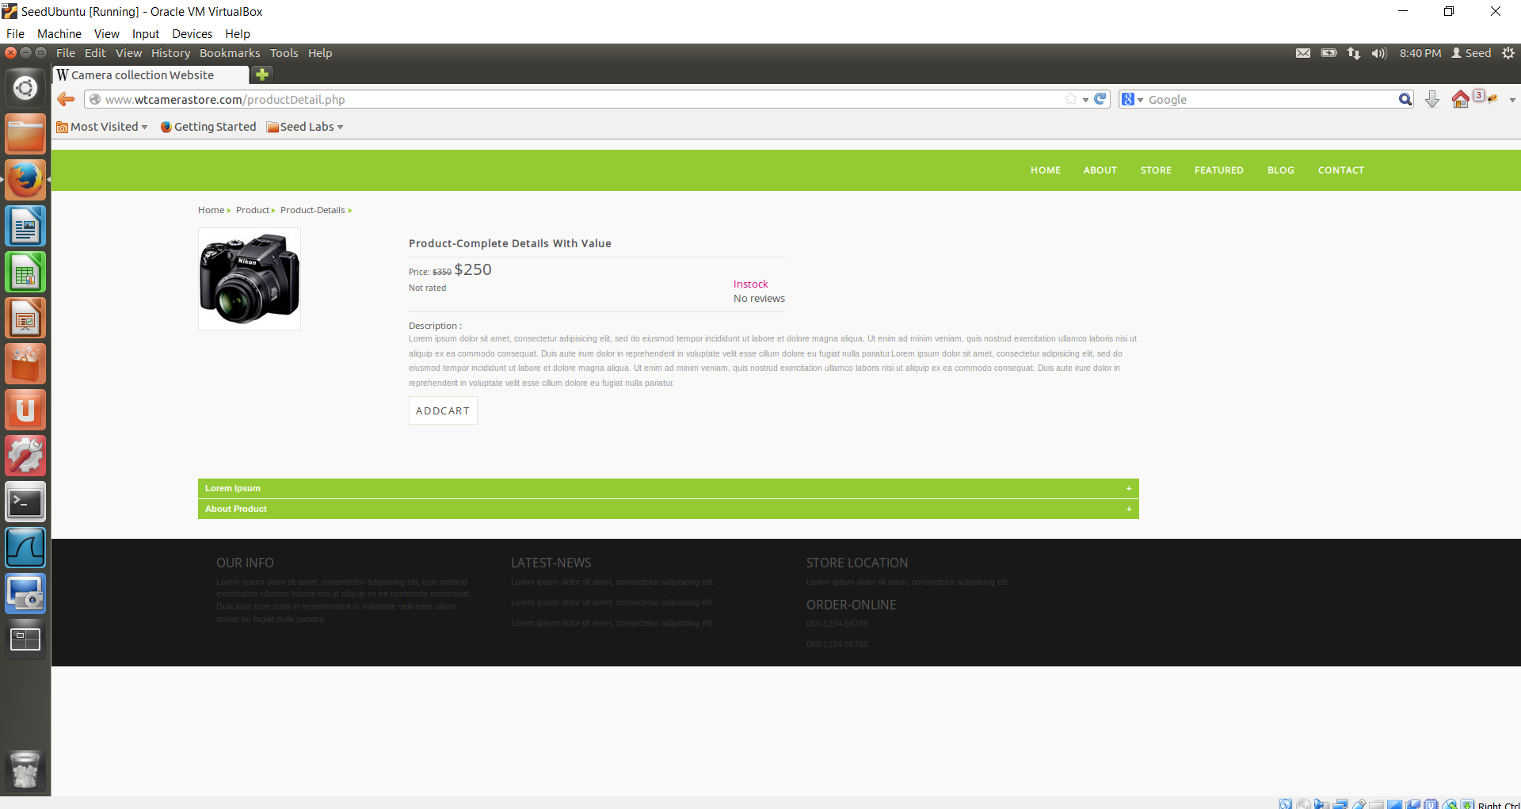

Access [***www.wtlabadserver.com/preferences.php***](http://www.wtlabadserver.com/preferences.php)*in another tab*, here, all the user activity is logged wherein the user is linked with a product, and the number of times the user has opened/accessed that particular product. (Details include: Product, Category, product GUID, number of time the user has visited the product and User tracking ID)

Here, the user is linked with the product via their ***userTrack IDs*** and the respective ***Product Guid***. The ***UserTrackID*s** are unique IDs assigned to a user.

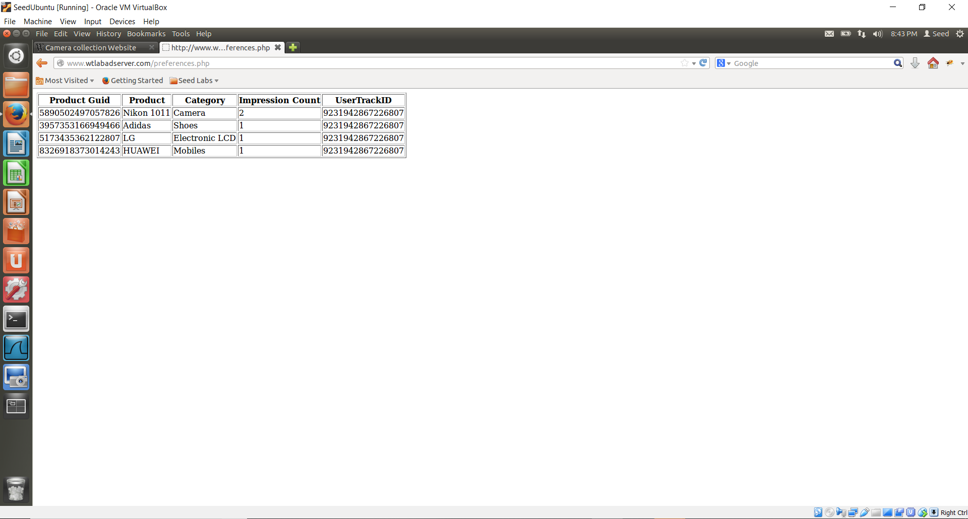

**Task 4:**

I opened the Elgg website (http://www.wtlabelgg.com), from the Firefox browser and through ‘Tools’, launched ***“Live HTTP headers”***. I then identified the ***HTTP request*s** that are from a different domain. The track id of a cookie is set in this product. The Elgg website displays targeted advertisements to the users based on the data collected through the cookies. The advertisements would be displayed for the product which has been visited the greatest number of times.

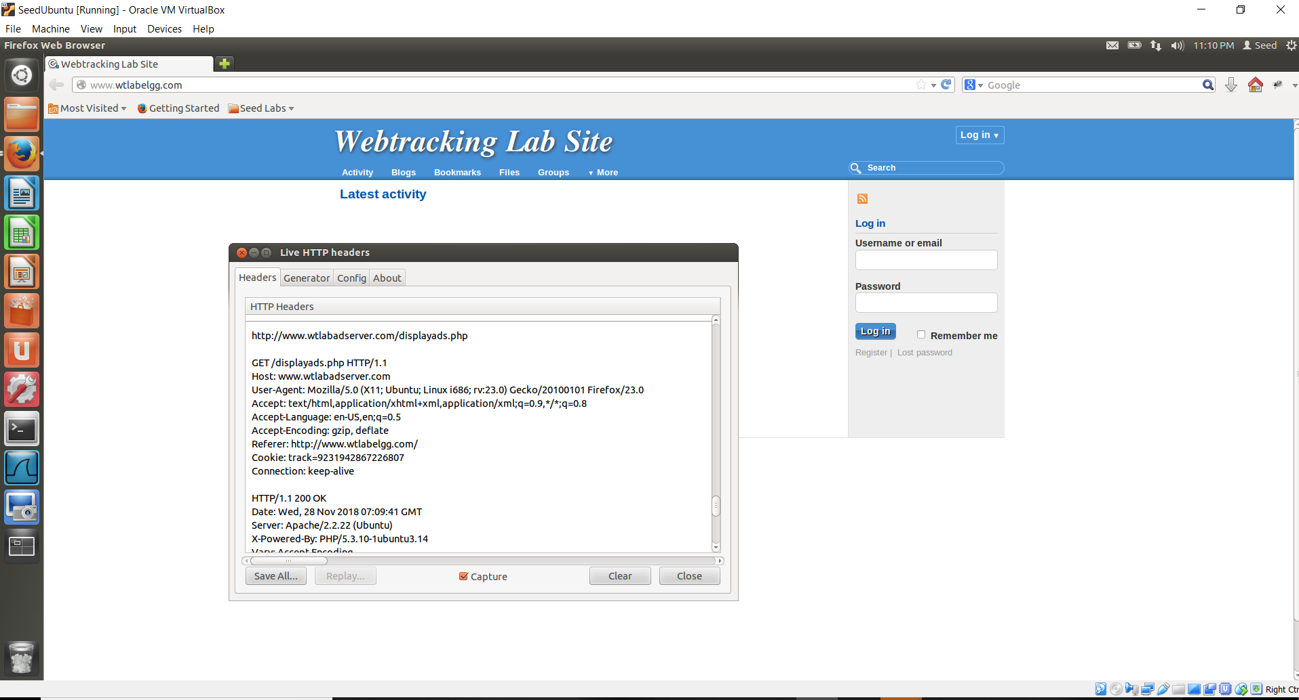

**Task 5:**

I opened up the Elgg (Webtracking lab) website in the private browsing mode and observed that no advertisements were displayed on the web page. This demonstrates that, if you are browsing through a private tab, the ***adserver*** will not keep track of your identity. In other words, the user will have a different identity.

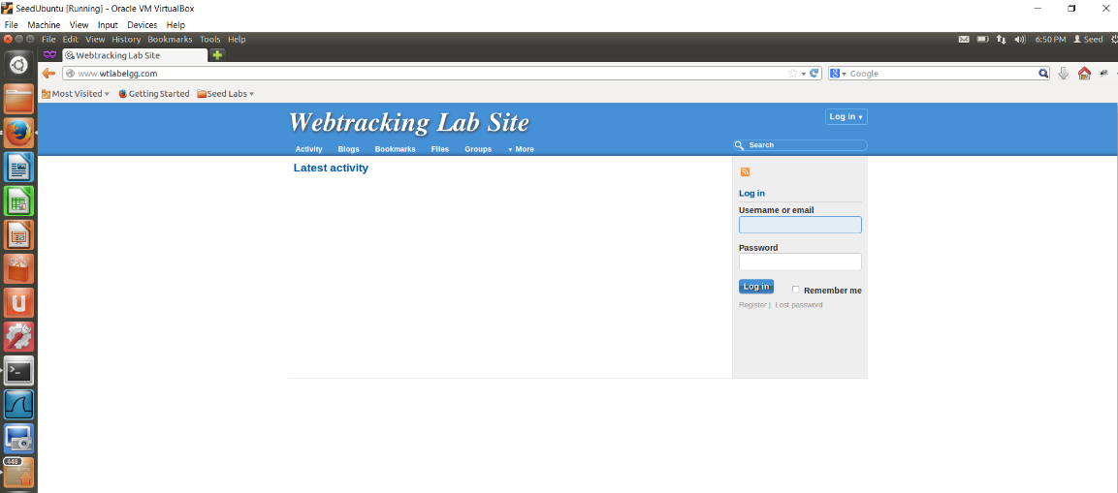

I clicked on ***“View details”*** of a product on an e-commerce website such as CameraStore.

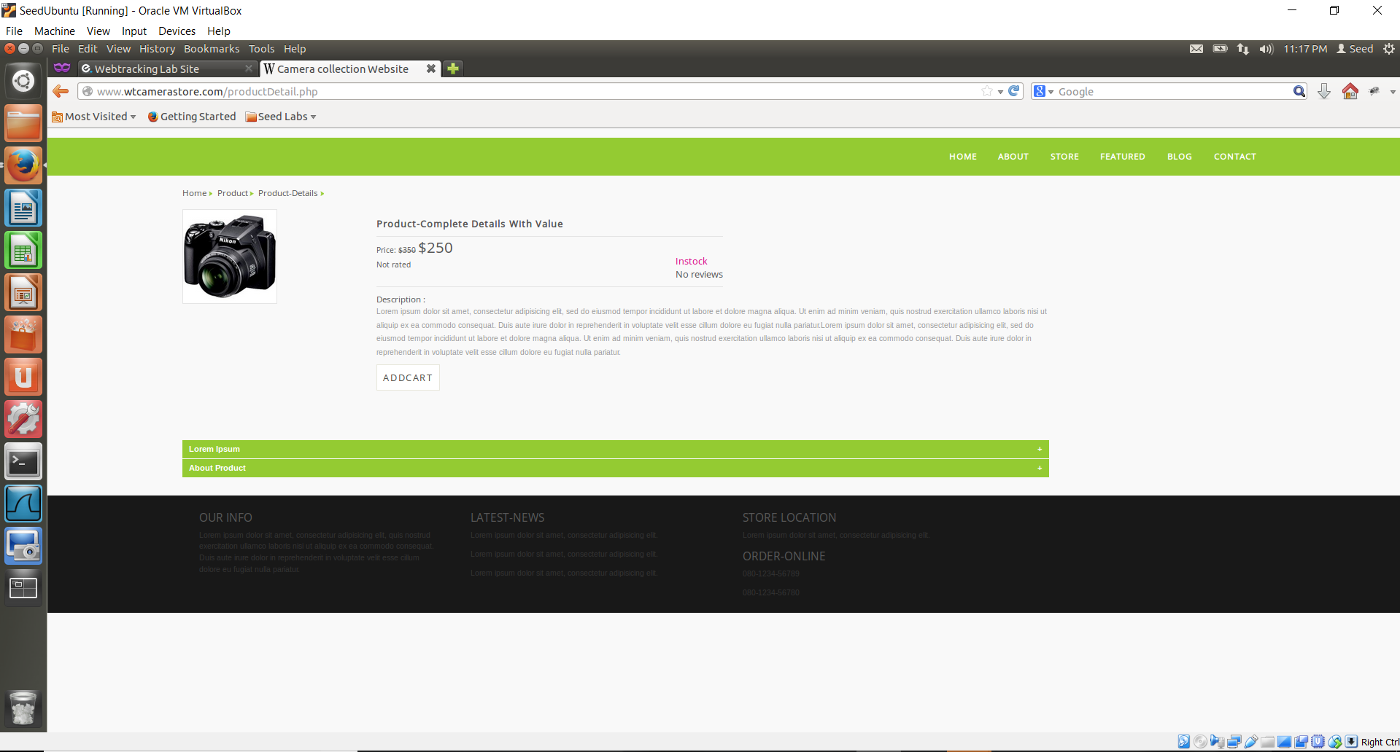

Then, when I refreshed the ***Elgg website***, I noticed that an advertisement for the camera which I visited previously from the private window was being displayed.

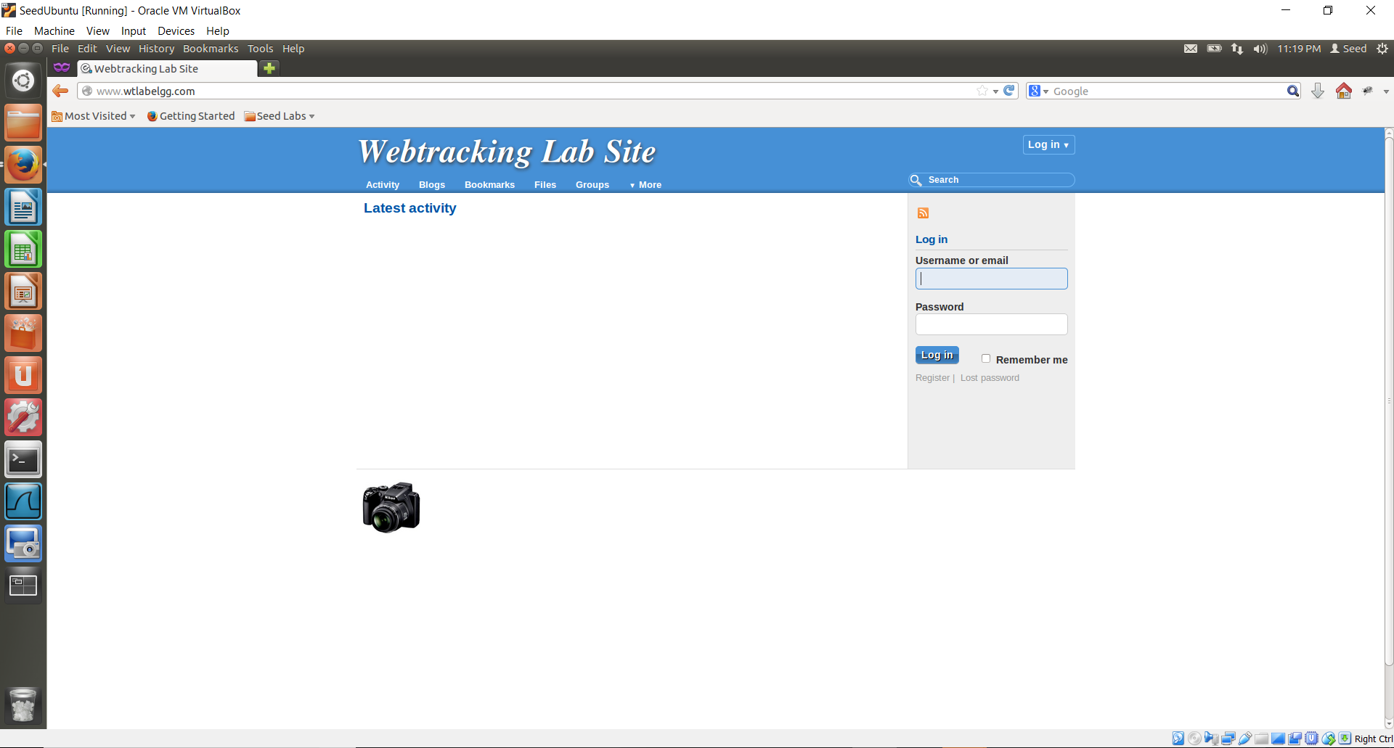

I then closed the Firefox browser and relaunched it. Then, I reopened the Elgg website and found that no advertisements are being displayed on the website now.

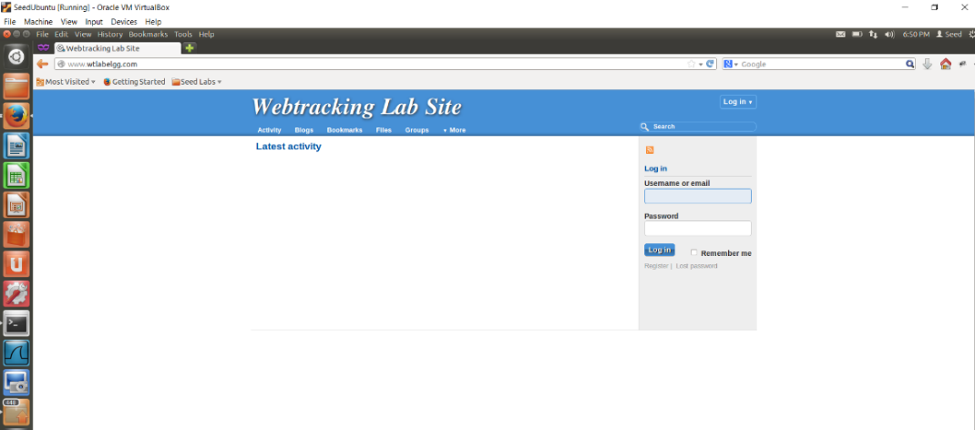

When compared to Task 1, it can be seen that upon closing the browser and then relaunching it, no advertisement is displayed. However, in Task 1, the same advertisement (which was seen before closing the browser) was displayed even after the browser was closed and then relaunched.

This tells us that, in a Private Browsing session, Firefox deletes all the cookies when the application is closed. Thus, upon relaunching Firefox, no advertisements are displayed.

**Task 6:**

I visited some real websites like <http://www.amazon.com> and <http://www.dictionary.reference.com> , on the Internet, and searched for the web requests using the ***“Live HTTP Headers”*** extension. From the below screenshots we can identify the third party cookie used for that HTTP request.

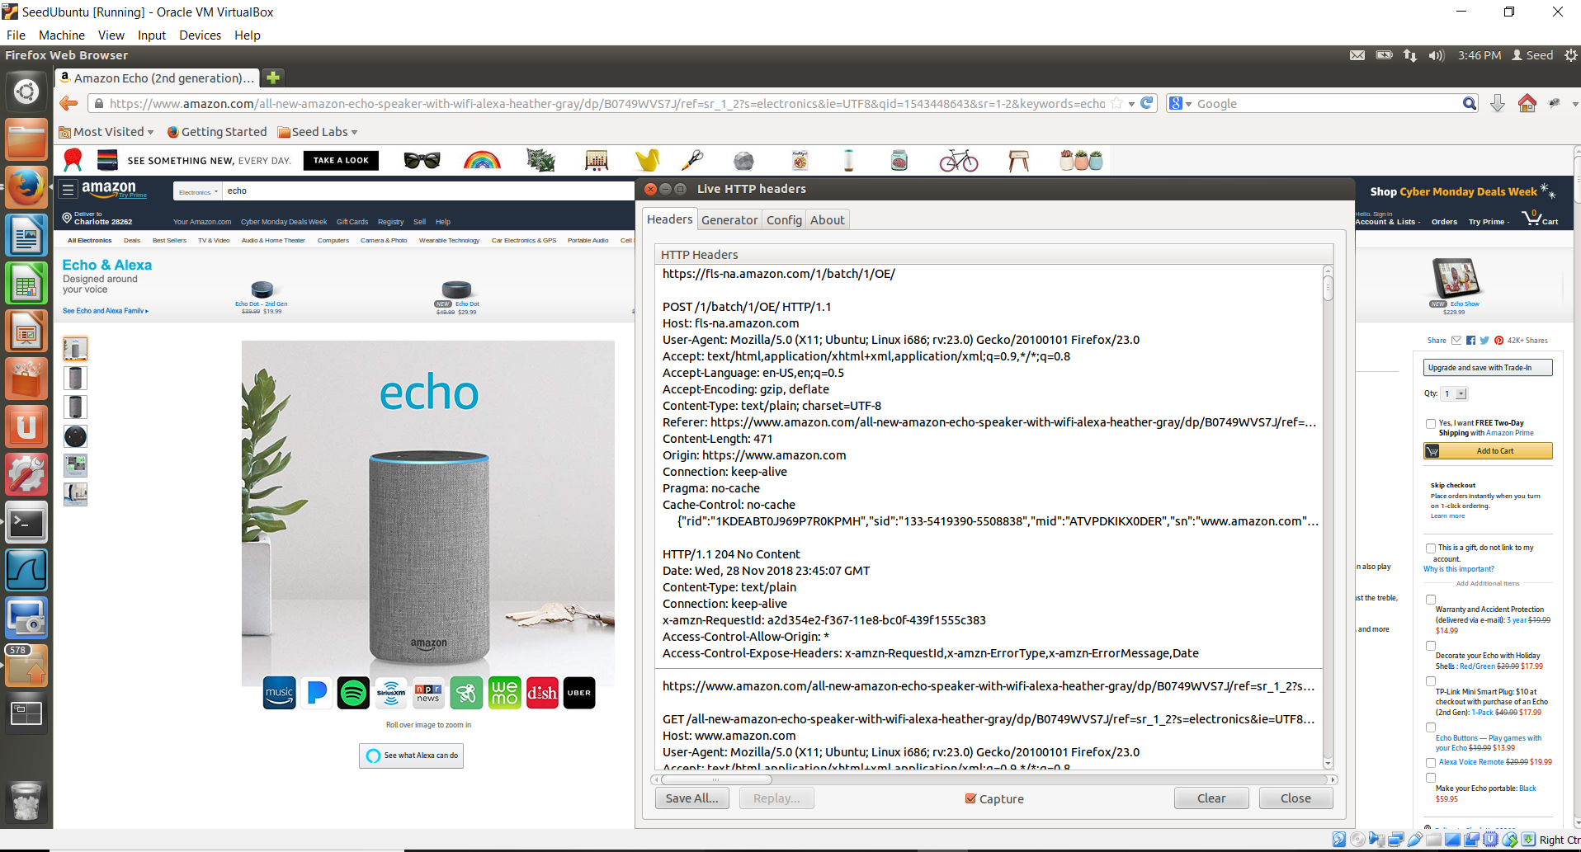

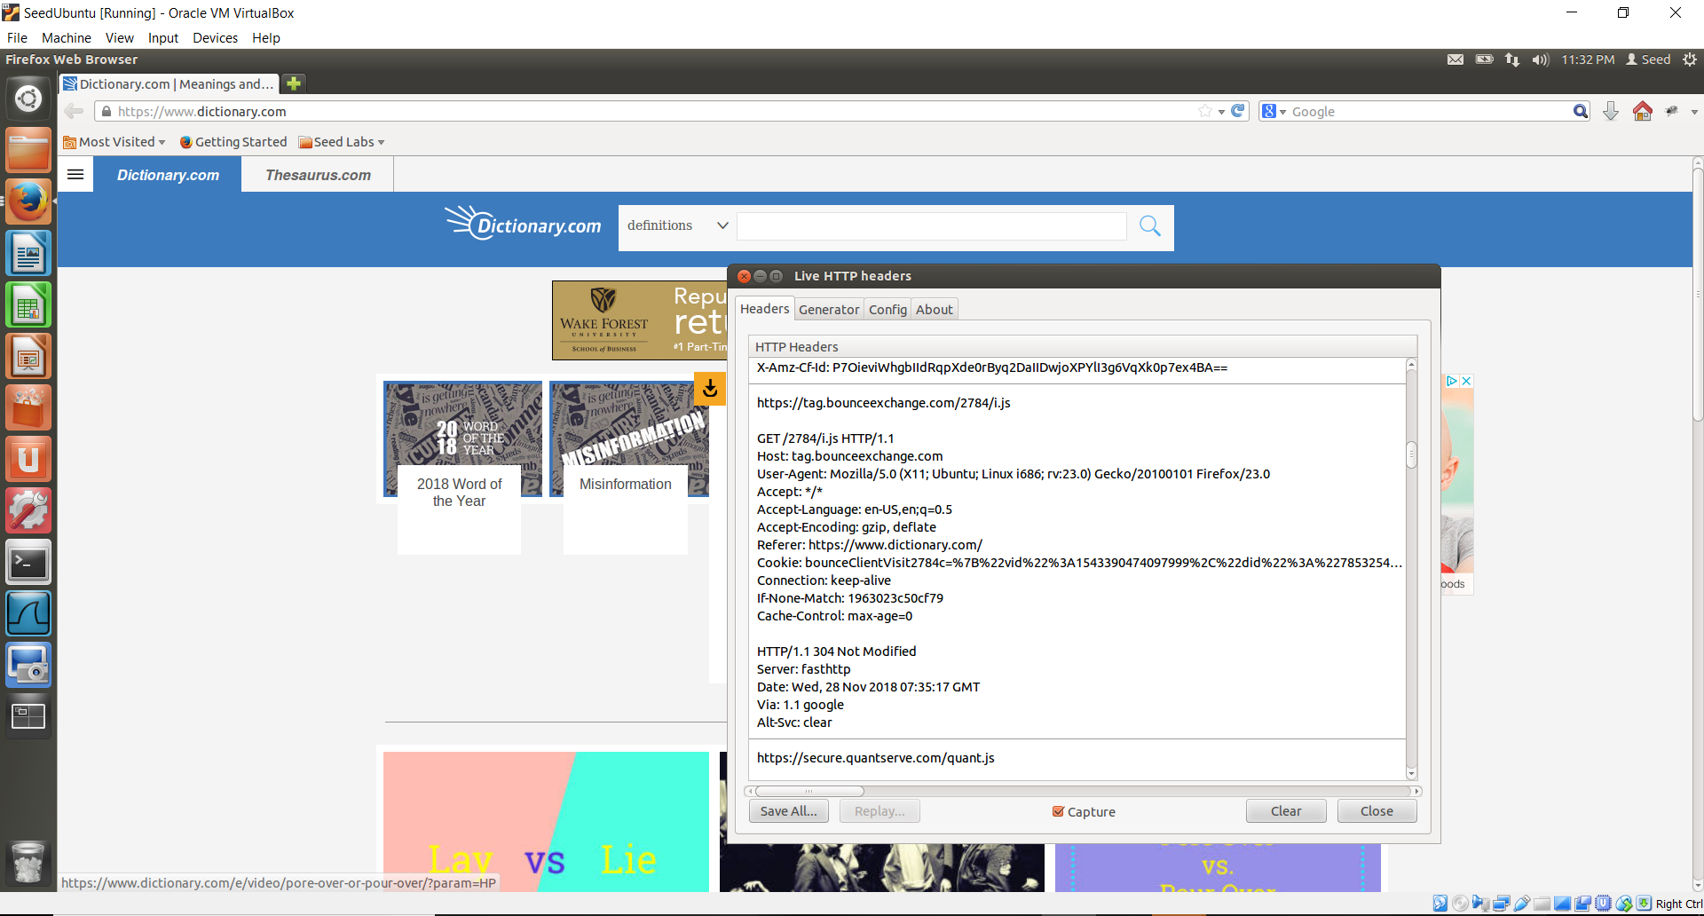

***I was unable to access the URL*** [***http://www.careerbuilder.com***](http://www.careerbuilder.com/)

**Task 7:**

To disable the Third Party cookies in the browser, I navigated to: **Edit->Preferences->Privacy->Use custom settings**. And in **“Accept Third Party cookies”** dropdown, I selected the option **“Never”**.

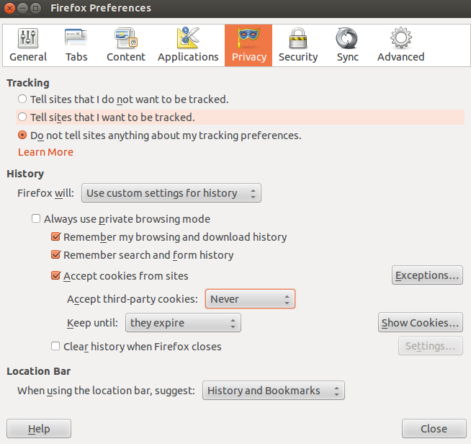

Then, I surfed one of the e-commerce websites [www.wtcamerastore.com](http://www.wtcamerastore.com) and clicked on the “View Details” of a product after opening the “Live HTTP Header” extension as shown below. Here, we can identify the HTTP request that was used to set the third-party cookies.

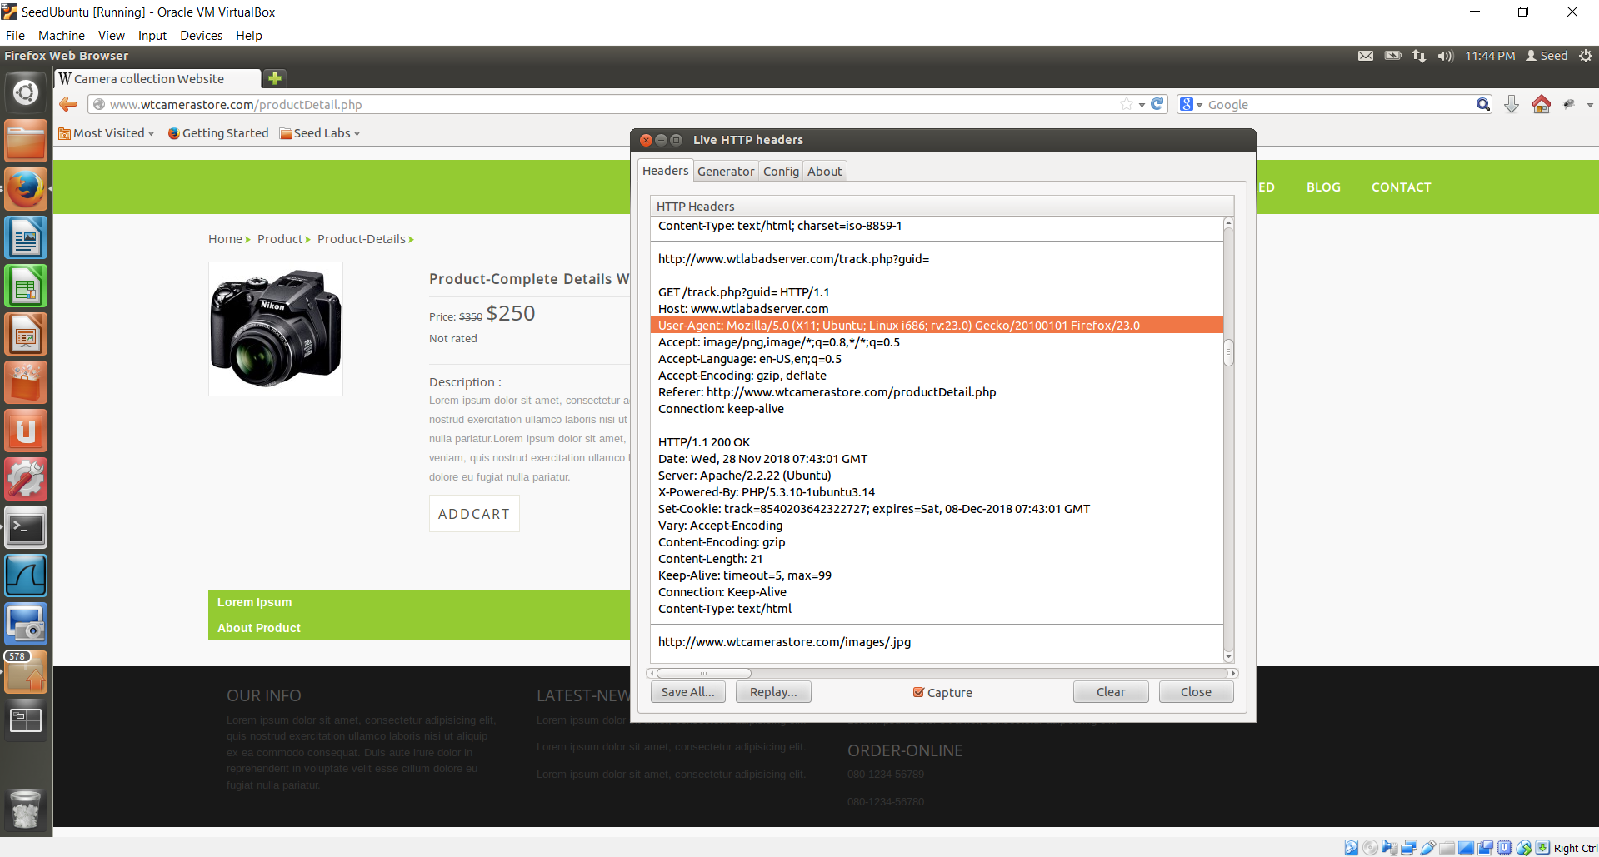

Now, when I opened the ***Elgg website***, I can see that there is no advertisement displayed on the webpage.

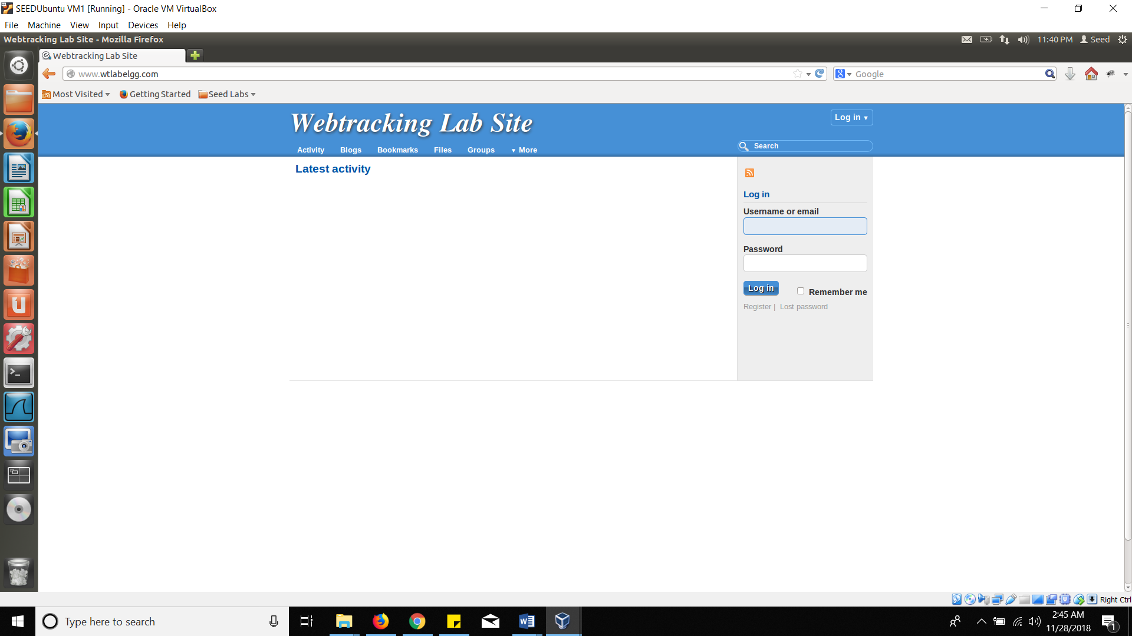

I found the HTTP request from the ***Elgg website*** using the ***“Live HTTP Headers”***. While comparing it to the one in Task 4, I can see that there is no Cookie set in this request. This is because the Third-Party cookies have now been disabled.

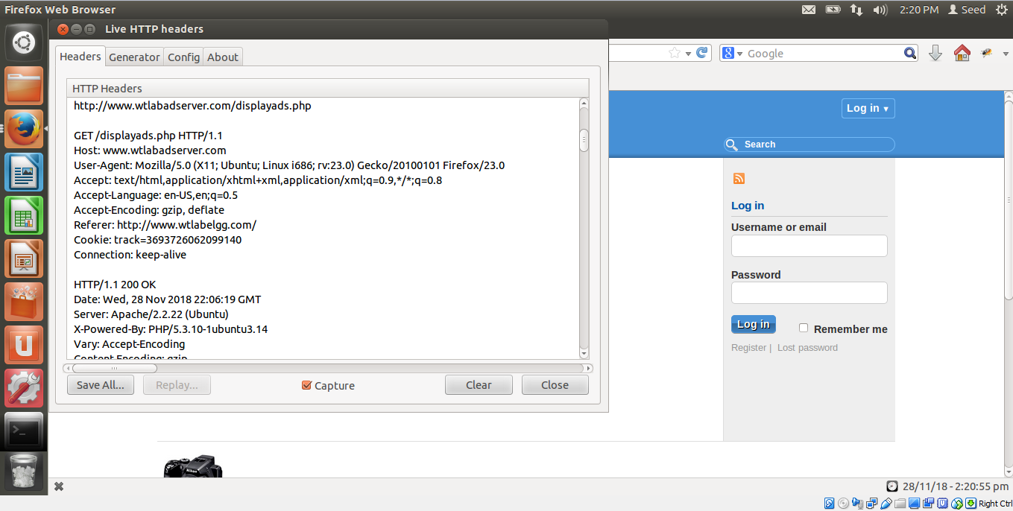

* Any surprising results that you see or you learn from the project.
* The first surprising result which I noted was that the advertisements of the E-commerce websites were not being displayed when I closed the InPrivate browsing tabs and reopened the Elgg website InPrivate Browsing.
* The second surprising result was finding the ‘***Do Not Track’*** option, which is basically a feature indicating that you have a choice of not letting the third-party track your preferences.